Images used to determine rewards rank will be emojis

🎖️🏅🥉🥇🥈🏆💎👑

Logo:

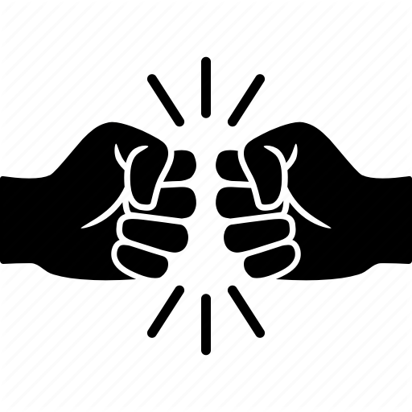

Source: <https://www.iconfinder.com/icons/3905997/bro_bump_fist_five_hands_pound_power_icon>

Route Planner Icon:

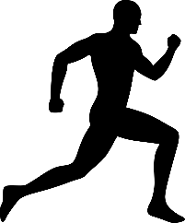

Source: <https://www.onlinewebfonts.com/icon/531817>

Exercise Icon:

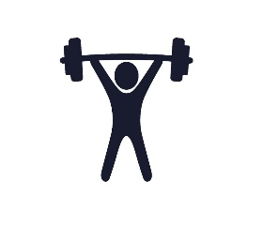

Source: <https://oneymca.org/gym_blog/beginners-body-weight-workout/whole-body-workout-icon/>

Calories Calculator Icon:

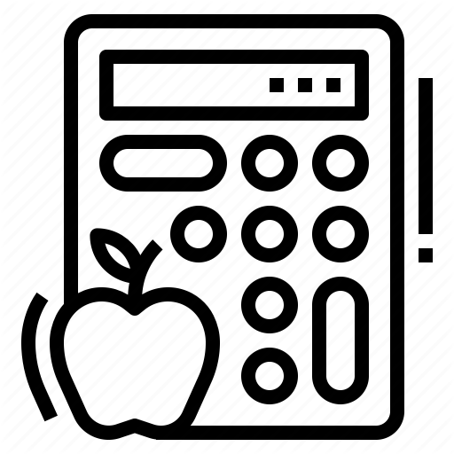

Source: <https://www.iconfinder.com/icons/4299262/calculator_calorie_fat_food_healthy_icon>

Events Calendar Icon:

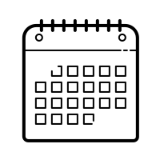

Source: <https://icons8.com/icons/set/calendar>

Account Icon:



Source: <https://www.pinclipart.com/pindetail/xbRxhi_account-customer-login-man-user-icon-login-icon/>

Meals Icon:

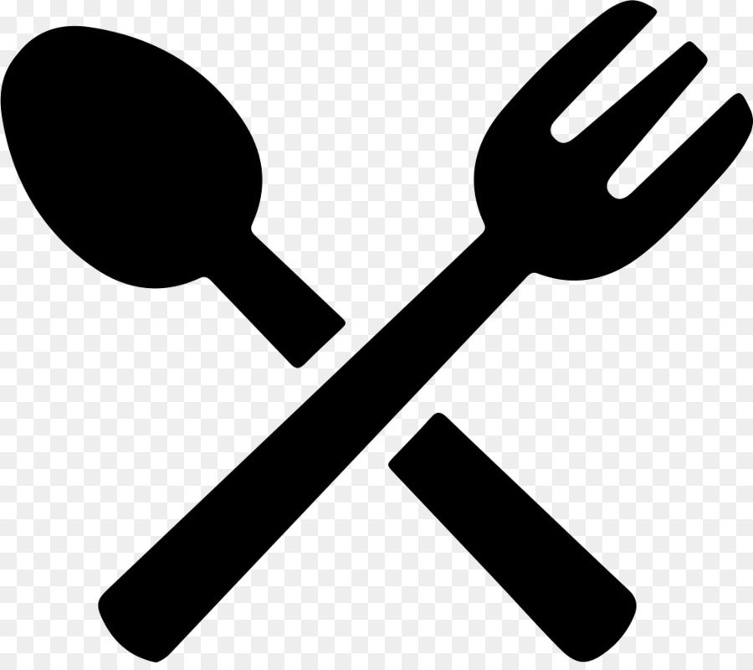

Source: <https://www.pinterest.ca/pin/8162843061099814/>